**Assignment 19.2:**

Using UDFs on dataframe

1. Change firstname , lastname columns into

Mr.first_two_letters_of_firstname<space>lastname

For example: Michael , phelps becomes Mr.mi phelps

**Loading RDD and creating the dataframe for RDD:**

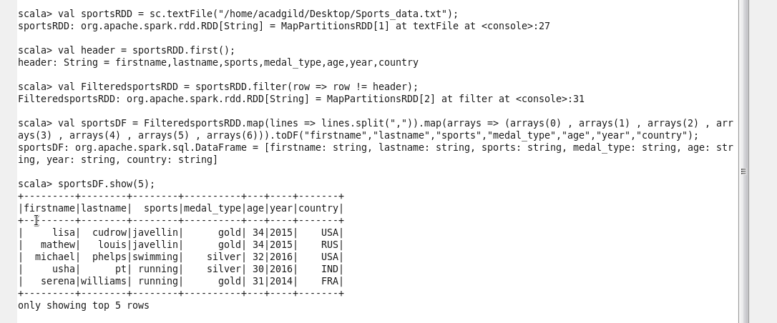

Creating the UDF which convert the first name with Mr.prefix and also drop the First and last name columns:

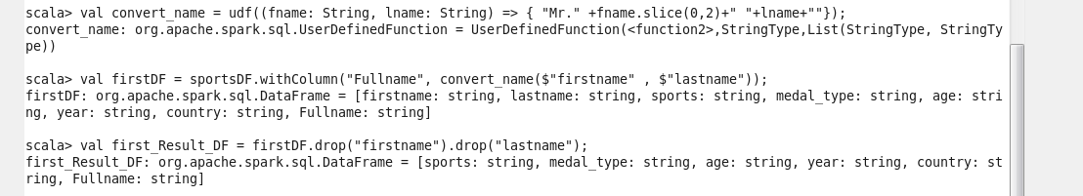

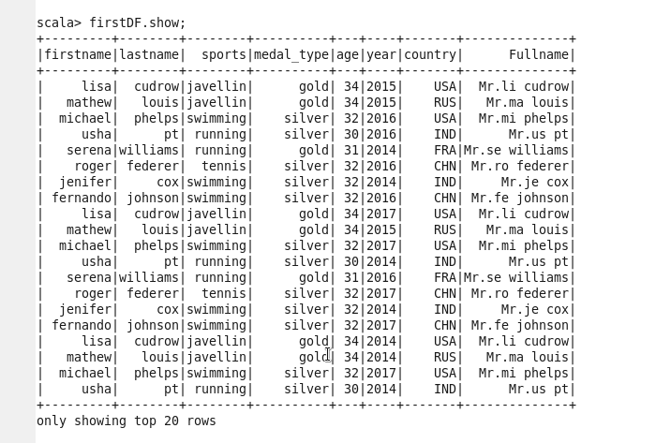

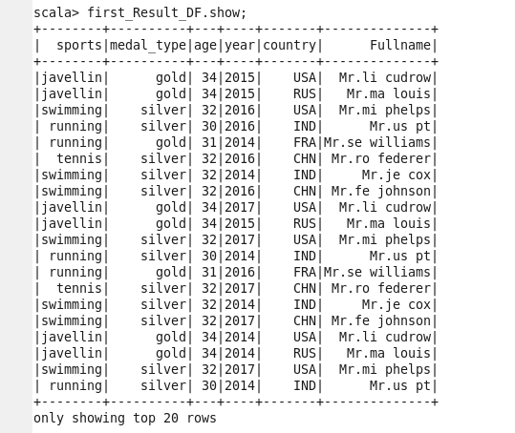

1. Add a new column called ranking using udfs on dataframe, where:

Gold medalist, with age >=32 are ranked as pro

Gold medalist, with age <=31 are ranked amateur

Silver medalist, with age >=32 are ranked as expert

Silver medalist, with age <=31 are ranked rookie

